Low-Level Design (LLD)

Real-Time AI Fraud Detection System — Proof of Concept

1. Module Breakdown

Module | File | Responsibility
Data Loader | data_loader.py | Load & clean public dataset
Feature Engineering | features.py | Compute velocity, amount, time features
Model Training | train.py | Train LightGBM, save artifact
Scoring API | api.py | FastAPI endpoint /score
Stream Replay | stream.py | Replay dataset as live events
Dashboard | dashboard.py | Streamlit live UI

2. Data Flow Diagram

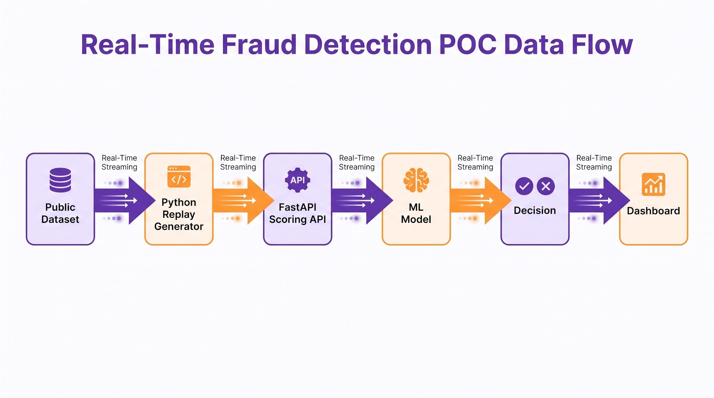

3. API Specification

POST /score
Request:

JSON
{
"transaction_id": "txn_123",
"amount": 250.0,
"merchant": "electronics_store",
"device_id": "dev_456",
"ip": "203.0.113.5",
"timestamp": "2025-01-01T10:00:00Z"
}

Response:

JSON
{
"transaction_id": "txn_123",
"fraud_score": 0.87,
"decision": "block",
"reason": "high_amount_velocity_anomaly"
}

4. Feature Engineering
- Amount — transaction value
- Velocity — count/sum of transactions in last 60 min
- Time — hour of day, day of week
- Device/IP — frequency & mismatch signals
- Merchant — category risk score

5. Model Details
- Algorithm: LightGBM (binary classification)
- Class imbalance: SMOTE / class weights
- Metrics: precision, recall, F1, AUC-ROC
- Threshold: tuned to balance false positives vs. fraud capture

6. Decision Logic

if fraud_score >= threshold: decision = "block"
elif fraud_score >= review_threshold: decision = "flag"
else: decision = "allow"

7. Database Schema (PostgreSQL)

Table | Columns
transactions | id, amount, merchant, device_id, ip, timestamp
decisions | txn_id, fraud_score, decision, reason, created_at
model_metrics | precision, recall, f1, threshold, updated_at

8. Component Diagram

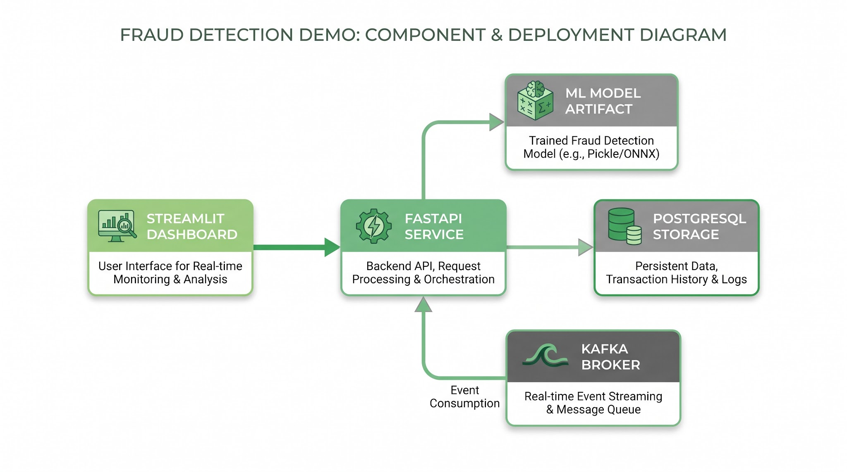

9. Deployment
- Local: run all services via Docker Compose
- Services: api, stream, dashboard, postgres
- Ports: API 8000, Dashboard 8501, Postgres 5432

10. Testing Plan
- Unit tests for feature engineering
- API tests for /score
- End-to-end: replay stream → verify decisions
- Load test: measure latency per request

